TECHNICAL REPORT WRITING FOR CA2 EXAMINATION



NAME- SANDIPAN CHAKRABORTY

STERAM- COMPUTER SCIENCE AND BUSINESS SYSTEM

ROLL NO – 18731122015

SUBJECT NAME- DATABASE MANAGEMENT SYSTEMS

SUBJECT CODE- PCC CSBS 502

YEAR- THIRD

SEMESTER- FIFTH

TOPIC- RELATION BETWEENCLOUD AND DATA WAREHOUSE

ABSTRACT:

This paper delves into the intricate relationship between cloud computing and data warehousing. It explores how the convergence of these two technologies has revolutionized data management and analytics. By examining the key benefits, challenges, and best practices, this paper provides valuable insights for organizations seeking to leverage the power of cloud-based data warehousing.

INTRODUCTION:

In today's data-driven world, organizations are faced with the challenge of managing and analyzing vast amounts of information. Data warehousing, a centralized repository for storing and managing data, has been a cornerstone of business intelligence for decades. However, the advent of cloud computing has introduced new possibilities and challenges.

This paper will investigate the synergy between cloud and data warehouse, exploring how they complement each other and drive innovation. We will discuss the key benefits of cloud-based data warehousing, such as scalability, cost-effectiveness, and agility. Additionally, we will examine the challenges that organizations may encounter when migrating their data warehouses to the cloud and provide strategies for overcoming them.

CONCEPT OF CLOUD AND DATA WAREHOUSING:

Cloud Computing: A computing model that delivers services over the internet, allowing users to access resources as needed, without the need for local infrastructure.
Data Warehousing: A centralized repository for storing and managing structured and semi-structured data from various sources, optimized for analytical processing.
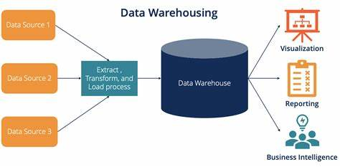
The intersection of cloud and data warehouse offers a powerful combination. Cloud-based data warehouses leverage the scalability, flexibility, and cost-effectiveness of cloud infrastructure to provide organizations with a robust and efficient platform for data analysis.
A cloud data warehouse is a system for storing and processing large amounts of structured and semi-structured data on cloud infrastructure. Examples include Amazon Redshift, Google BigQuery, Snowflake, and Microsoft Azure Synapse Analytics.
On-premises data warehouses are costly and require purchasing hardware and software. Today, data analytics is crucial for business operations, generating revenue, minimizing costs, and improving customer satisfaction.
To meet these requirements, organizations need robust data warehouse solutions that can grow, be reliable, have strong security features, and handle various data formats and big data scenarios.
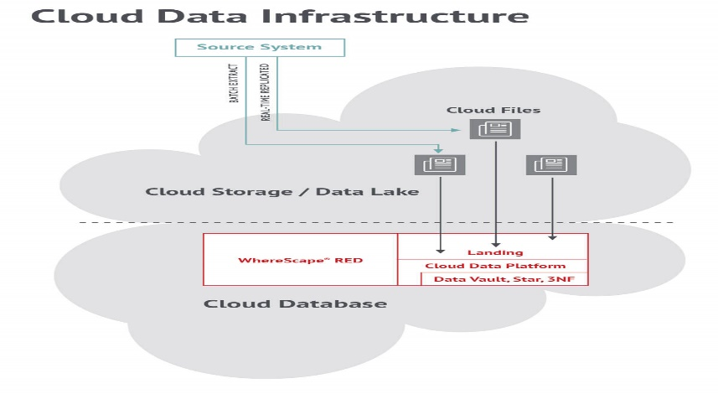

HOW DATA WAREHOUSING WORKS:

Data warehousing is a process of collecting, storing, and analyzing data from multiple sources for decision-making purposes. It involves transforming raw data into a structured, analytical format that can be easily queried and analyzed.
Here's a breakdown of the key steps involved in data warehousing:

1. Data Extraction:
- Source Identification: Identifying all relevant data sources, such as databases, flat files, and transactional systems.
- Data Extraction: Extracting data from these sources using various techniques like ETL (Extract, Transform, Load) tools or APIs.

2. Data Transformation:
- Cleaning and Standardization: Cleaning the data to remove inconsistencies, errors, and duplicates. Standardizing data formats and ensuring data integrity.
- Data Integration: Combining data from multiple sources into a unified view.
- Data Transformation: Applying business rules and logic to transform the data into a format suitable for analysis.

3. Data Loading:
- Loading Data: Populating the data warehouse with the transformed data.
- Scheduling: Setting up schedules for regular data updates to ensure the data warehouse remains current.

4. Data Storage:
- Data Warehouse Architecture: Designing the physical structure of the data warehouse, including tables, dimensions, and facts.
- Data Storage: Storing the data in a specialized data warehouse appliance or database system optimized for analytical queries.

5. Querying and Analysis:
- Querying: Using SQL or other query languages to retrieve specific information from the data warehouse.
- Analysis: Applying analytical techniques like OLAP (Online Analytical Processing), data mining, and reporting tools to uncover insights and trends.

6. Data Visualization:
- Visualizations: Creating charts, graphs, and dashboards to present data in a visually appealing and understandable format.
- Insights: Providing decision-makers with actionable insights based on the analysis.

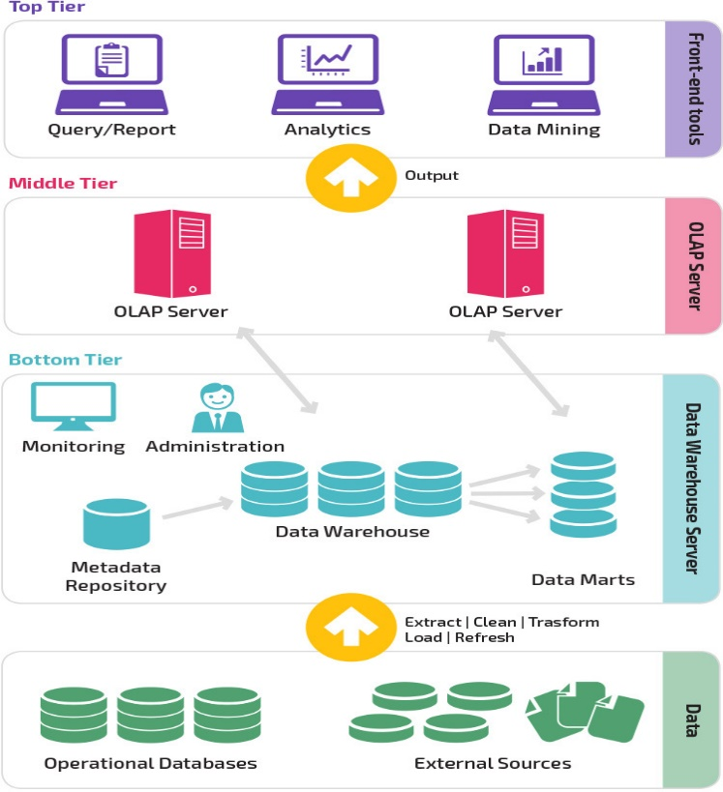

7.Key Benefits of Cloud-Based Data Warehousing:

- Scalability: Cloud data warehouses can easily scale up or down to meet changing data volumes and processing demands.
- Cost-Effectiveness: Pay-as-you-go pricing models and reduced infrastructure costs make cloud-based data warehousing a cost-effective option.
- Agility: Rapid deployment and provisioning of resources enable organizations to respond quickly to changing business needs.
- Accessibility: Cloud-based data warehouses can be accessed from anywhere with an internet connection, promoting collaboration and accessibility.

8.Challenges and Considerations:

- Data Security: Ensuring the security and privacy of sensitive data stored in the cloud is a top priority.
- Performance: Network latency and potential performance limitations can impact query response times.
- Vendor Lock-in: Reliance on cloud providers can create vendor lock-in, limiting flexibility and potentially increasing costs.
- Migration Complexity: Migrating an existing data warehouse to the cloud can be a complex and time-consuming process.

CONCLUSION:

The convergence of cloud and data warehouse has ushered in a new era of data management and analytics. By leveraging the benefits of cloud computing, organizations can unlock the full potential of their data and gain valuable insights to drive informed decision-making.

As the cloud landscape continues to evolve, it is essential for organizations to stay informed about emerging trends and technologies. By understanding the relationship between cloud and data warehouse, and by adopting best practices, organizations can harness the power of these technologies to achieve their business objectives.

REFERENCES:

A Deep Dive into Cloud Data Warehousing | Teradata
Data Warehouse Architecture: Traditional vs. Cloud Models | Panoply
Database vs. Data Warehouse: Differences, Use Cases, Examples (couchbase.com)

